CREATE AND CONFIGURE IBM CLOUD SERVICES

**Team id:** PNT2022TMID50986

**Project title:** Personal Assistance for seniors who are Self-reliant

1. **CREATE IBM WATSON IOT PLATFORM & DEVICE:**

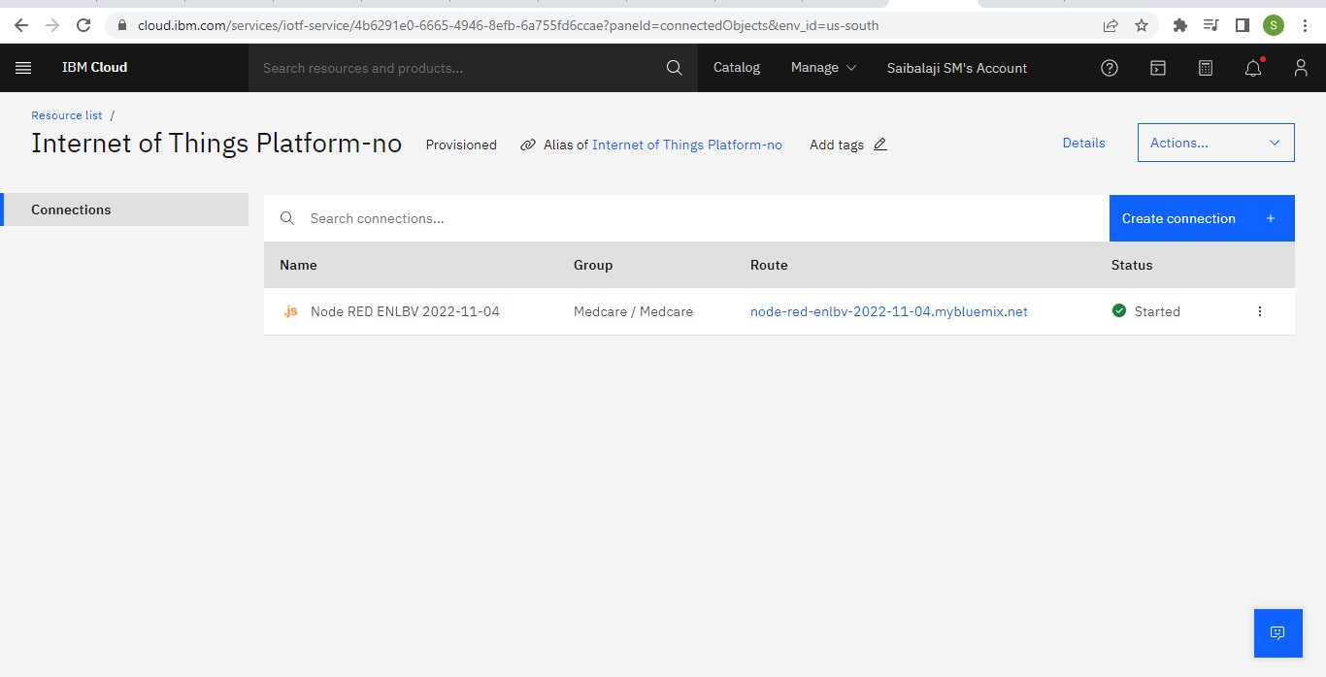

1. **CREATE NODE RED SERVICE:**

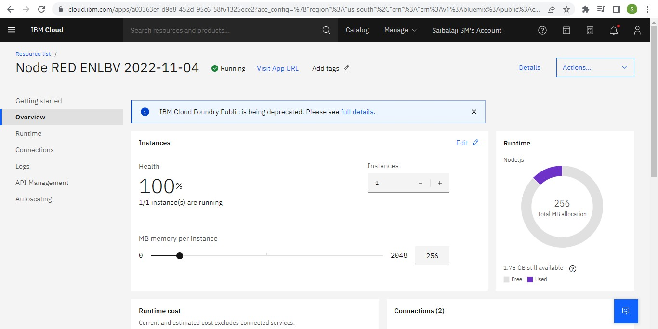

1. **CREATE TEXT TO SPEECH SERVICE:**

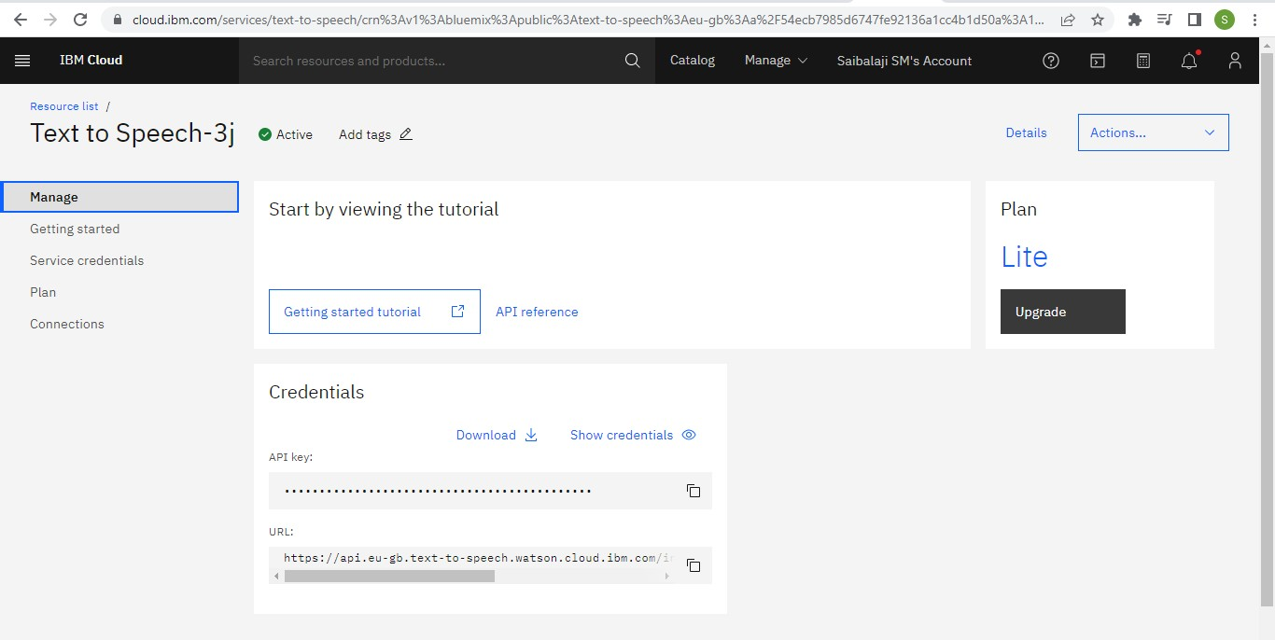

1. **CREATE A DATABASE IN CLOUDANT DB:**

